Name: _______________________________________________
Foundation Unit 19 topic test
Date:
Time: 40 minutes
Total marks available: 34
Total marks achieved: ______

Questions
Q1.
These shapes have been drawn on a grid of centimetre squares.
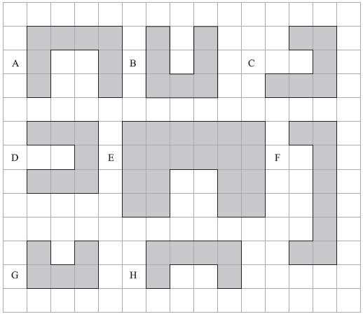
(a) (i) Write down the letters of a pair of shapes that are congruent.
..............................................................................................................................................
(ii) Write down the letters of a different pair of shapes that are similar.
..............................................................................................................................................
(2)
(b) Find the perimeter of shape D.

..............................................................................................................................................
(1)
(Total for Question is 3 marks)

Q2.
Six shapes are drawn on the grid.
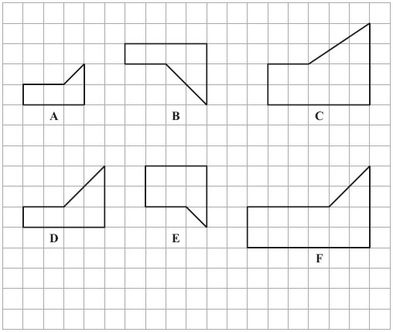
Two of the shapes are congruent.
(a) Write down the letters of these two shapes.
..............................................................................................................................................
(1)
One of the shapes is similar to shape A.
(b) Write down the letter of this shape.
..............................................................................................................................................
(1)
(Total for Question is 2 marks)

Q3.
(a) A shaded shape is shown on the grid.
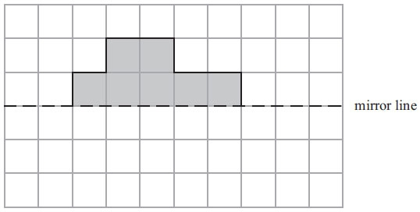
Reflect the shaded shape in the mirror line.
(1)
(b)
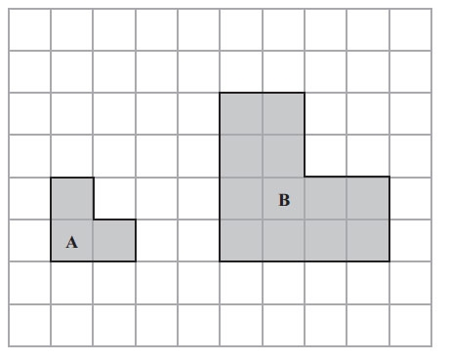
Shape B is an enlargement of shape A.
Write down the scale factor of the enlargement.

..............................................................................................................................................
(1)
(c) On the grid, draw two parallel lines.
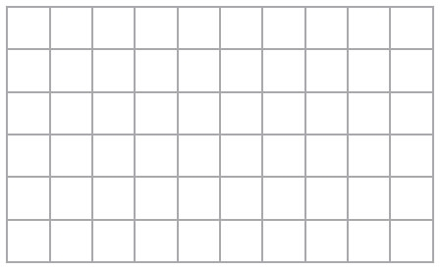
(1)
(d) Here are some shapes.
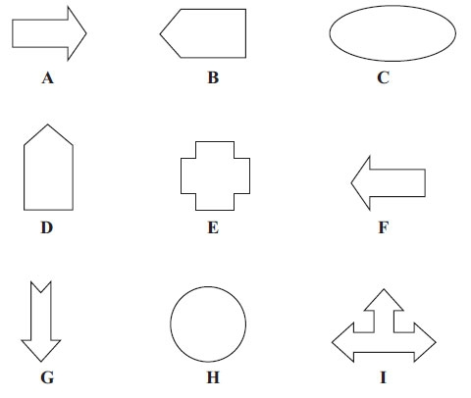
Write down the letters of two shapes that are congruent.

..............................................................................................................................................
(1)
(Total for Question is 4 marks)

Q4.
Here are some triangles drawn on a grid.
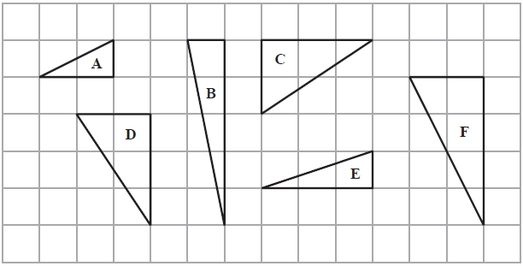
Two of the triangles are congruent.
(a) Write down the letters of these two triangles.
........................................................... and ...........................................................
(1)
One of the triangles is an enlargement of triangle A.
(b) (i) Write down the letter of this triangle.
...........................................................
(ii) Write down the scale factor of the enlargement.
...........................................................
(2)
(Total for Question is 3 marks)

Q5.
A small photograph has a length of 4 cm and a width of 3 cm.
Shez enlarges the small photograph to make a large photograph.
The large photograph has a width of 15 cm.
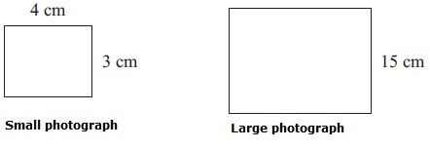 Diagram NOT accurately drawn
The two photographs are similar rectangles.
Work out the length of the large photograph.

..............................................................................................................................................
(Total for Question is 3 marks)

Q6.
The diagram shows two rectangles.
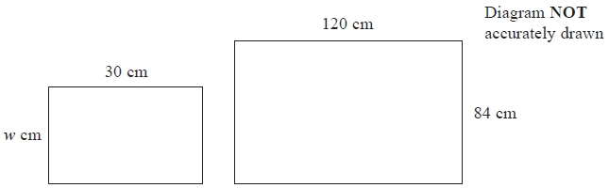
The rectangles are similar.
Work out the value of w.
...........................................................
(Total for question = 2 marks)

Q7.
The smallest angle of a triangle is 25º
The triangle is enlarged by scale factor 3
Ben says,
"The smallest angle of the enlarged triangle is 75º because 25 × 3 = 75"
Is Ben right?
Explain your answer.
.............................................................................................................................................
.............................................................................................................................................
(Total for question = 1 mark)

Q8.
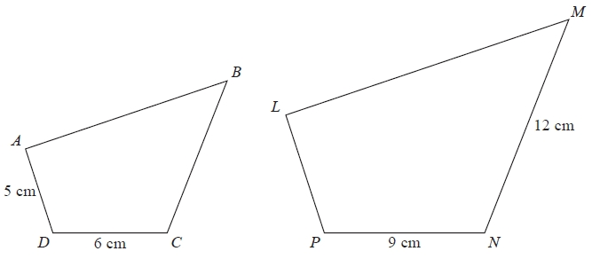
Diagram NOT accurately drawn
Quadrilaterals ABCD and LMNP are mathematically similar.
Angle A = angle L
Angle B = angle M
Angle C = angle N
Angle D = angle P
(a) Work out the length of LP.
...........................................................cm
(2)
(b) Work out the length of BC.
...........................................................cm
(2)
(Total for Question is 4 marks)

Q9.
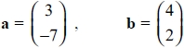
Work out b − 2a as a column vector.
...........................................................
(Total for question = 2 marks)

Q10.
Triangle PQR is similar to triangle PRS.
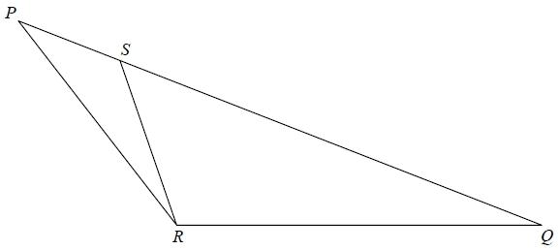
PSQ is a straight line
Angle PQR = angle PRS.
PS = 2 cm.
PR = 5 cm.
Work out the length of SQ.

(Total for question = 3 marks)

Q11.
Here is a star shape.
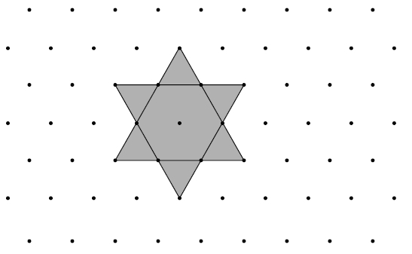
The star shape is made from a regular hexagon and six congruent equilateral triangles.
The area of the star shape is 96 cm².
Work out the area of the regular hexagon.
........................................................... cm²
(Total for question = 2 marks)

Q12.
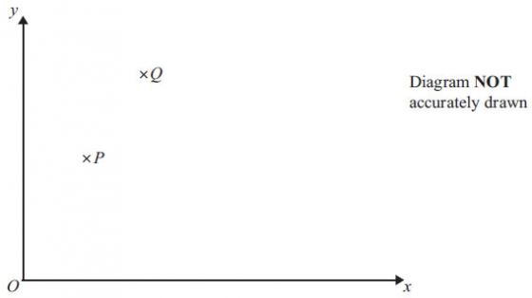
The diagram is a sketch.
P is the point (2, 4)
Q is the point (4, 8)
(a) Find the vector
Give your answer as a column vector 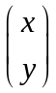

..............................................................................................................................................
(2)
= 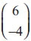
M is the midpoint of PQ.
N is the midpoint of QR.
(b) Find the vector 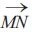
Give your answer as a column vector

..............................................................................................................................................
(3)
(Total for Question is 5 marks)

Examiner's Report
Q1.
Very few candidates gained full marks in part (a); the majority, however, gained 1 mark for the selection of shapes B and D in either part (a)(i) or part (a)(ii). In selecting B and D in part (a)(ii) only, many candidates failed to show complete understanding of the differences between congruence and similarity.
Although the correct answer of 16 was the most common response in part (b), many candidates still mix up area and perimeter, with an answer of 7 being seen many times.

Q2.
Almost all candidates were able to give the congruent shapes but the success rate dropped significantly when it came to finding the shape that is similar to shape A.

Q3.
In part (a), virtually all candidates correctly completed the reflection of the shape in the mirror line.
However in part (b), only about three-quarters of candidates could write down the correct scale factor of enlargement with 3, 4 or 9 being the most common incorrect responses.
In part (c), the majority of candidates could draw a pair of parallel lines, although many perpendicular lines were drawn. A large number of candidates drew either a rectangle or a parallelogram, but most failed to score as very few indicated distinct pairs of parallel lines.
In part (d), the majority of candidates could identify one of the pairs of congruent shapes. However some candidates did not seem to understand the concept of congruence and appeared to look at the shapes as if being asked for the odd one out. As a result, many of the incorrect responses were C and H, as they were the only two without straight edges.

Q4.
Finding the congruent shapes was well answered, but many candidates could not find the triangle that was enlargement of triangle A as C and D were often given as the most common wrong answers. Interestingly though, many candidates could give the correct scale factor as 2 even without the correct answer for part (b)(i) being given.

Q5.
Many candidates found this question straightforward with over 70% of them obtaining at least 2 out of the 3 marks available. Where candidates did lose one mark it was often because they omitted units (cm) in their answers. Conversely there were candidates who scored 1 mark for correct units but did not have a correct method to find the length of the enlarged photograph. A small number of candidates successfully found the length then went on to calculate the perimeter or area of the photograph.

Q6.
A high percentage of students completed this question on similar rectangles successfully They usually used a scale factor approach.

Q7.
No Examiner's Report available for this question

Q8.
Candidates generally scored full marks or no marks. Those who were successful usually worked out the scale factor, preferring to express this as 1.5 rather than ⁹⁄₆. Some did go on to use this incorrectly in part (b), multiplying by 1.5 instead of dividing. Using ratios of sides was rarely seen.
The most common error was to view the relationship as one involving addition and subtraction rather than a multiplicative relationship: the most frequent incorrect answers were LP = 8 and BC = 9. These results obtained from 9 − 6 = 3, and 5 + 3 = 8 and then for the second part 12 − 3 = 9

Q9.
No Examiner's Report available for this question

Q10.
No Examiner's Report available for this question

Q11.
No Examiner's Report available for this question

Q12.
Few candidates used a fully algebraic approach and it was extremely rare to find the equation 3x +2=26 being successfully reached and then solved. Most candidates used a numeric approach, scoring at least one mark for showing three ages that added to 26 or giving at least three trials. Some candidates who tried to use algebra gave the expression 4x for Peter's age instead of x+4.

Mark Scheme
Q1.
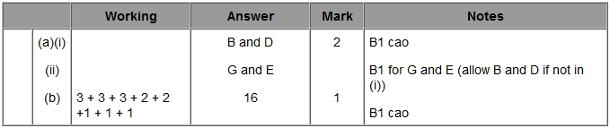

Q2.
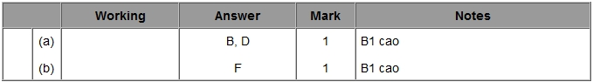

Q3.
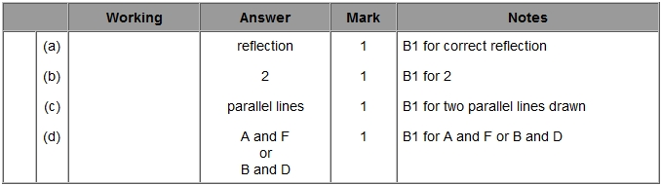

Q4.
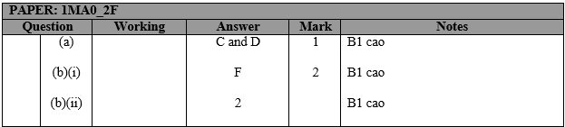

Q5.
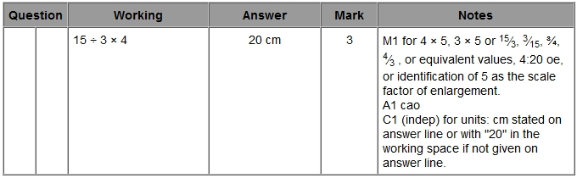

Q6.
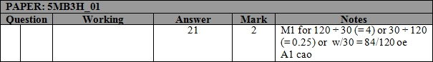

Q7.
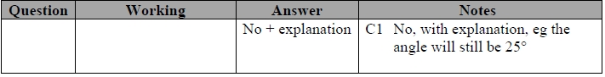

Q8.
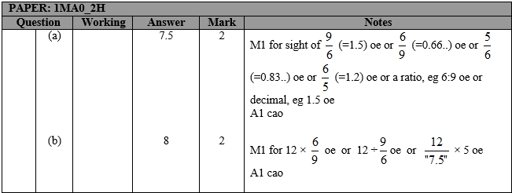

Q9.
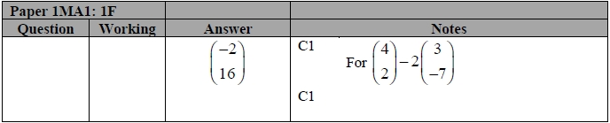

Q10.
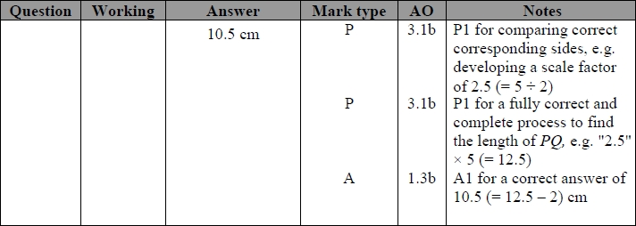

Q11.
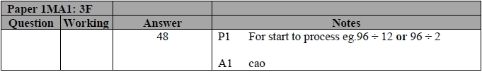

Q12.
